# **Problem Statement & Objectives**

## Problems

**1. Manual & Unstructured Visit Planning**

User Problem: Manual visit planning is time-consuming, reactive and leads to process inefficiencies.

Pain Points:

* City Heads/ASMs assign doctors via WhatsApp groups with **no structured schedule,** which farmers track
* Farmers decide their own visit timings within the week, leading to **inconsistent follow-ups & engagement**
* No prioritisation based on **risk of churn or potential** to grow business - Left to individual’s decision

**2. Lack of Doctor Context During Visits**

User Problem: Farmers lack insights, key account info, recent queries during visits, leading to ineffective conversations.

Pain Points:

* No easy & quick access to basic **doctor account-level information** (e.g., total orders placed, earnings generated, app adoption, trends).
* Unable to personalize conversations or pitch based on the doctor’s **past behavior or potential**.
* Farmers are caught off-guard when doctors enquire about their **queries already raised with support**

**3. Limited Visibility & Tracking for Leadership**

User Problem: City leads and ASMs lack real-time visibility into visit completion and meeting effectiveness.

Pain Points:

* Meeting **completion is reviewed retrospectively** via weekly Lystloc exports, without any real-time/previous day’s visibility or alerts.
* **Feedback** from visits are captured in Lystloc check-out forms, which remain in static sheets—no accessible meeting history or insights.
* Currently a **5 step manual process** for leads to ensure all assigned doctors were met within the week.
* Leadership cannot easily analyze performance patterns, missed visits, or recurring issues in field execution.

## Objectives

1. **Reducing manual effort** & Automate visit planning with intelligent, prioritised task assignments. (Savings in terms of manhours)
2. **Introducing prioritisation** basis the increasing risk of churn (AR7 & AR40) as well as potential of business growth from from power users (Reduced AR7 & AR40 buckets, increasing business from power users)
3. **Equipping farmers with relevant account-level insights** at the point of visit along with details of queries that doctor had recently raised with support, to drive more impactful conversations and build stronger doctor relationships (Improve Saved% from AR40/AR7 segments).
4. **Enabling structured tracking of scheduled tasks and visits**, along with visibility into adherence and quality of execution, to improve accountability and outcomes (Improve coverage %)

# **User Insights**

For ASMs/City Heads, managing farming team, prioritising work, and tracking visit adherence involves the following steps, which are long & takes up significant amount of their working hours:

**Daily task planning:** From Central Sales Dashboard, download partner-wise order data for their city -> Export to sheets -> Paste in his formula sheet -> Has last month data in another sheet for comparison -> Identified Zero order accounts MTD, check AR7/AR40 & compare to previous day to see who got saved, which account has come new into the AR bucket -> Inactive accounts are shared to Individual farmers asking them to meet those accounts

**Checking of Visit Adherence:** (done weekly once) - Go to Lystloc -> Download weekly data & add to G-Sheet-> Filter out for his team -> From Meeting Notes, extract Partner ID (which is added manually by agents during visit) -> Add the data to a formula sheet -> Shows visits were done against a partner or not -> Compares that with at-risk accounts published

As far as Farmers are concerned:

* Those who go for visits with some planning & preparation, has to pull the partner level order data from central sales dashboard by themselves, add it in a sheet, and understand against their portfolio doctors, how many orders were placed and what was the revenue they got, but many farmers don’t do this, and purely try to convince doctors to place an order
* They follow & try to cover the lists shared by leadership, in terms of meeting inactive doctors, as well for pushing active users to become a power user
* They are caught off-guard when doctors whom they are visiting, asks the about any if the recent chat support queries they would have raised

Interviewed 3 farmers & 1 ASM, excerpts of the same are shared in the [doc](https://docs.google.com/spreadsheets/d/1uYB76PhP9M6SWGdf7Hh_RhjOcwm82lI60HSfwMJmFQ8/edit?gid=0#gid=0).

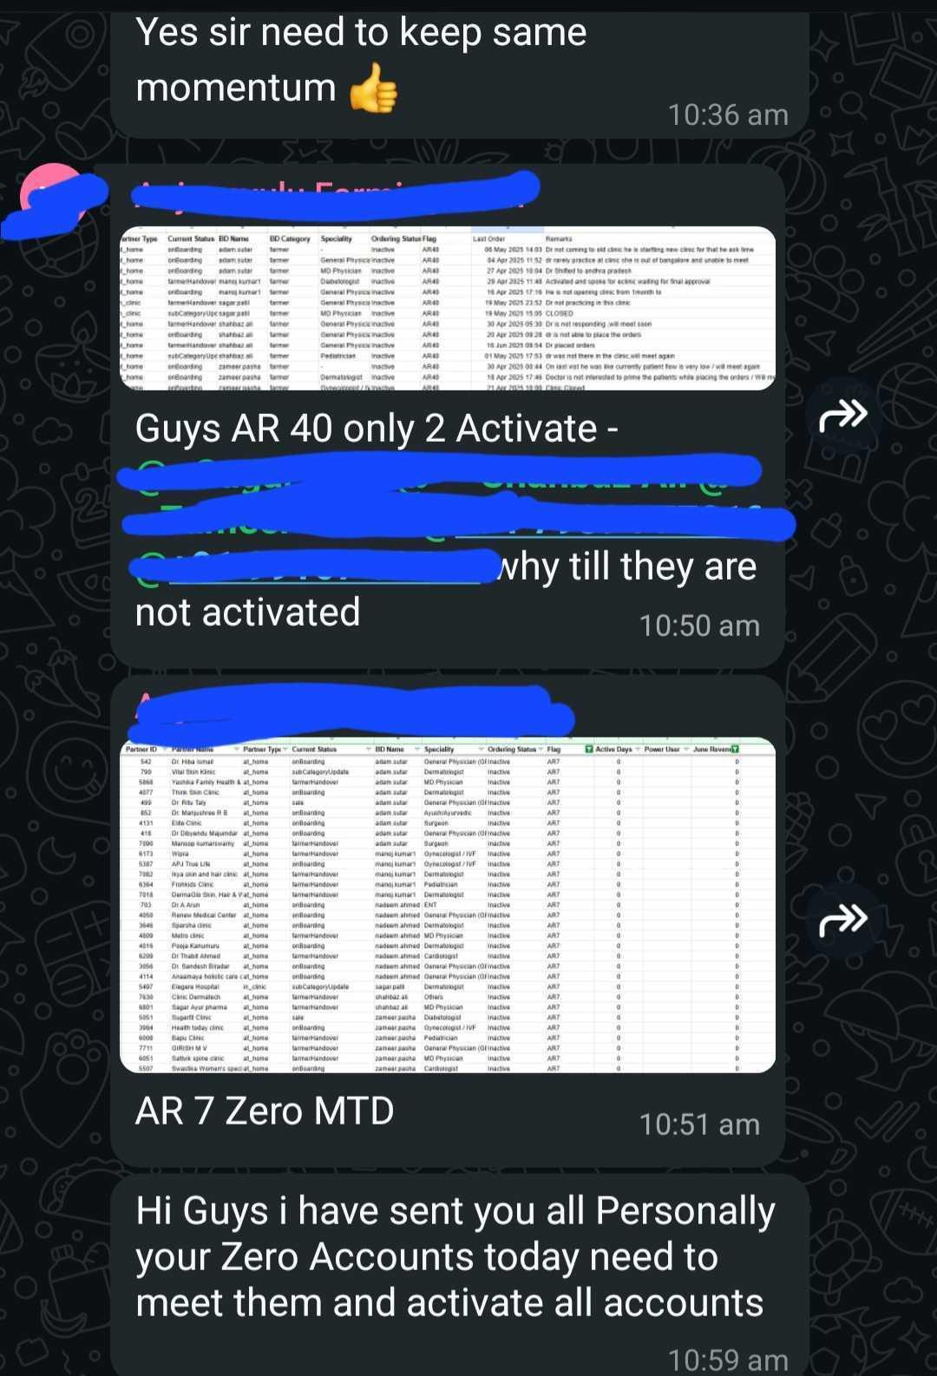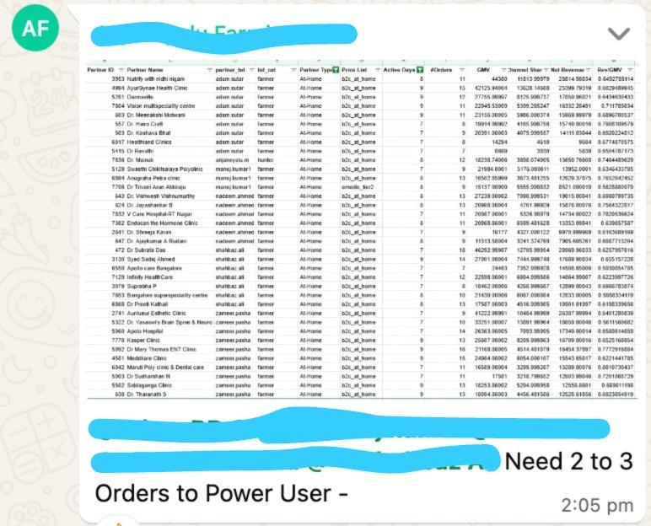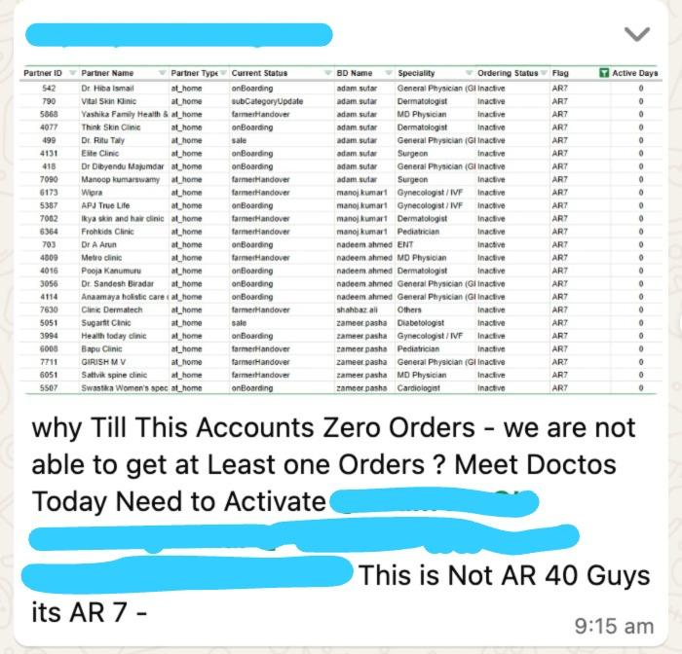

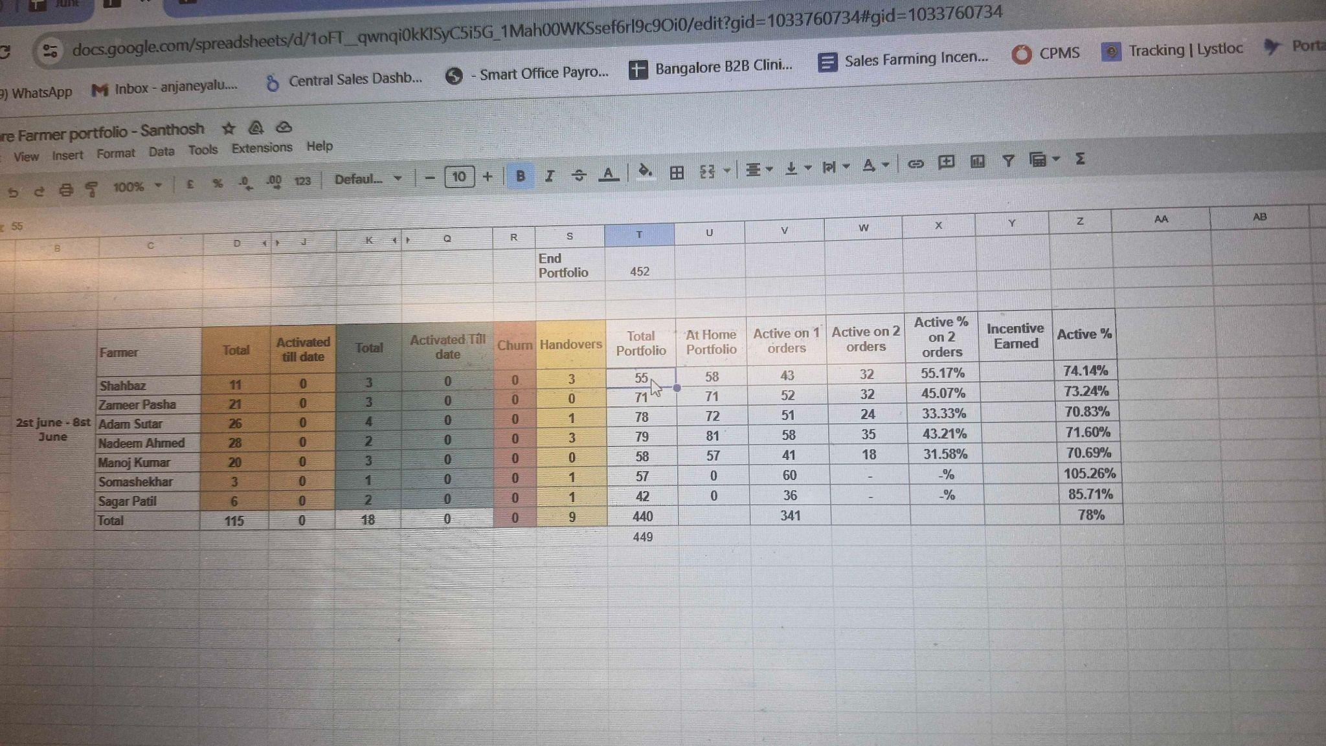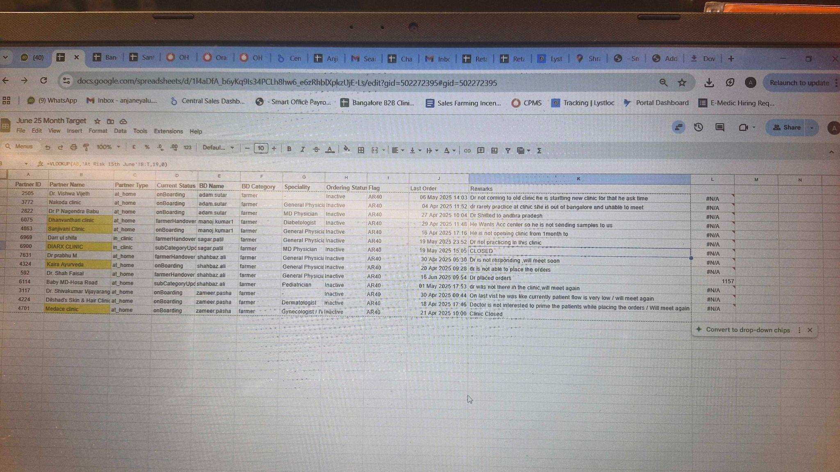

# **Solution Options Evaluated**

| **Solution option** | **Description** | **Pros** | **Cons** |
| --- | --- | --- | --- |
| Lystloc - LystCRM feature & corresponding API integration | Allows tasks to be created & assigned from Platform. Key meeting info can also be shared along with task. Confirmation on API integration capability raised with support team - awaiting response | Platform is already being used, and hence lesser friction for adoption.  Engg. bandwidth usage restricted mainly to the API creation & integration flow | Depends on external API; account info display is limited  Limitation to the way in which account info can be showcased |
| Using e-Medic App as a base for a separate flow for Farmers | Capabilities to assign tasks, Schedule, provide context for each appointment can be made use along with prioritisation | In-house built, avoiding complexities that can come with external party integration  Basic entities, flows & infra is already existing | Training required; adoption friction |

# **Solution to be built & reasons**

**Chosen Solution:**

Hybrid model using **Lystloc's task scheduling, location tracking, and in-app task view** with integrated **Orange Health data layer for insights** in Compass**.**

Following would be the major action items of the solution:

1. **Tagging of Accounts in OH backend**
2. **Have mapping of the field agents & account locations in OH backend**
3. **Defining & creating tasks for every farmer daily & pushing to Lystloc**
4. **Reading task adherence, location & visit feedback details from Lystloc**
5. **Web view of Compass to have Insights & other helpful sections**
6. **Structuring of data so as to be visualized & tracked effectively by Leadership**

## **Tagging of Accounts in OH backend**

#### 🔹 **Objective**:

To enable intelligent automation of field farming tasks by assigning meaningful, dynamic **tags** to each doctor account in Orange Health backend, based on real-time behavioral, transactional, and operational signals. These tags will:

* **Drive prioritised, daily task creation** for farmers (visits, calls, messages)
* **Reduce manual effort** by ASMs/City Heads for account planning
* **Improve field productivity** by surfacing the right accounts at the right time
* **Enhance doctor engagement** and conversion through data-backed interventions

#### 🔹 **Scope**:

This tagging system will:

* Run **daily**, generating a **snapshot of tags** for every active doctor in the system
* Cover doctors assigned to field farmers only (as per farmer–doctor mappings)
* Pull signals from orders, app usage, CRM (support tickets) & onboarding info to decide on the tasks
* Be used to:
  + Trigger or suppress task creation
  + Set task type (visit, call, message)
  + Set task priority (high, medium, low)
* Store historical tags for future trend analysis and audit purposes

#### **🔹 Tagging Themes**

All tags fall under four high-level strategic themes:

| **Theme** | **Goal** |
| --- | --- |
| **Churn Risk Detection** | Identify doctors who are slipping and need immediate attention |
| **Growth & Upsell Opportunity** | Identify doctors with increasing potential or untapped value |
| **Operational & Support Issues** | Flag accounts with blockers (support, payments, etc.) |
| **Compliance & Setup Gaps** | Identify incomplete onboarding/documentation issues |

#### 

#### **🔹 List of Tags**

| **Tag Name** | **Category** | **Logic (Sample)** | **Purpose** |
| --- | --- | --- | --- |
| AR4,AR7 AR14, AR21, AR28, AR40 | Churn Risk | No order in X days (where X = 4,7, 14, 21, 28, 40) | Prioritise recovery |
| Emerging Power User | Growth | 2+ orders in last 7 days with increasing trend (similar trend for last 3 weeks) | Deepen engagement |
| Power User | Growth | 10 orders in last 30 days | Maintain relationship |
| Low Engagement | Risk | App installed, low activity, <2 orders post onboarding | Push reactivation |
| WA Booker Only | Behavior | Orders via WhatsApp, low/no app usage | Nudge app adoption |
| High App Usage | Healthy | Daily app logins, report views, actions | No action needed |
| Support Heavy | Operational | >2 tickets raised in last 14 days | Prioritise visit |
| Negative CSAT | Operational | Recent ticket with CSAT < 3 or Negative experience in feedback form | Rebuild trust |
| No KYC, Pending PAN | Compliance | Missing required documents | Push via call/message |
| Newly Onboarded | Setup | Onboarded within last 7 days | Drive first order |
| Inactive Post First Order | Risk | Lifetime 1 order, then inactive for 14+ days | Understand drop-off |
| Stable Orderer | Healthy | Max 2 orders every week for last 4 weeks, not high volume | Passive monitor |

To keep the system lean, the following tag combinations will **exclude doctors from daily task creation**:

| **Tag(s)** | **Reason for Exclusion** |
| --- | --- |
| Power User **only** | Stable & performing, no nudge required |
| Stable Orderer **only** | Low-value but regular — deprioritised |
| High App Usage **only** | Engaged, no intervention required |
| Newly Onboarded < 3 days | Let onboarding cycle complete |
| *(No Tags)* | Not in any active segment — neutral |
| No Orders + recent visit done | Avoid over-touching cold leads |
| Pending PAN **only** | Passive compliance reminder via ops |
| Blacklisted / Do Not Contact | Exclude by rule |

#### **🔹 Tag Storage & Historical Tracking**

To enable time-based analytics and trend tracking:

| **Field** | **Type** | **Purpose** |
| --- | --- | --- |
| doctor_id | UUID | Unique ID for the doctor |
| tag_name | String | Tag assigned |
| snapshot_date | Date | Date when tag was applied |
| source | String | Derived from Compass, CRM, support, etc. |
| created_at | Timestamp | Audit purposes |

**Primary Key:** (doctor_id, tag_name, snapshot_date)

This design enables:

* Historical tracking of tag evolution
* Ability to query tag transitions (e.g., AR40 → Power User)
* Debugging or backtracking past farmer-task mismatches

#### **🔹 Tag Usage in Task Assignment**

Each tag maps to one or more **task types** (Visit, Call, Message) and a **priority level**:

| **Tag** | **Task Type** | **Priority** |
| --- | --- | --- |
| AR40, AR14 | Visit | 🔴 High |
| Emerging Power User | Visit | 🔴 High |
| Support Heavy | Visit | 🔴 High |
| No KYC, Pending PAN, AR3 | Call / Message | 🟠 Medium / 🟢 Low |
| WA Booker Only | Message | 🟢 Low |

Tags that **don’t map to any actionable state** will not generate a task.

#### **🔹 Next Steps After Tagging** Once tags are assigned daily:

1. Tags are **joined with farmer–doctor mappings**.
2. Task engine filters out:
   * Doctors without task-worthy tags
   * Duplicate open tasks
   * Doctors with existing tasks in recent days
3. The final set of **ranked, de-duplicated tasks per farmer** is pushed to Lystloc API.

### **2. Mapping of Field Agents & Partner Clinic Locations (OH ↔ Lystloc)**

#### **🔹 Objective:**

Ensure correct mapping between Orange Health’s backend and Lystloc for accurate visit task creation and adherence tracking.

#### **🔹 What Needs to Happen:**

1. **Partner Clinics Mapping:**Use existing clinic data in OH backend (partner ID, name, address, coordinates) to **create Customer records in Lystloc**.
   * These customer records will be used to assign visit and non-visit tasks.
   * Accurate clinic location is critical, as it will define **whether a farmer’s check-in counts as a valid visit**.
2. **Field Agent Mapping:**
   * Farmers already use Lystloc accounts for daily check-ins.
   * These **Lystloc user IDs must be mapped to farmer IDs in OH backend**, so that tasks are correctly assigned and adherence can be tracked.

Following are the **fields that will be needed to create customers (doctors) in Lystloc** -> LystCRM module.

* **Customer Code** – Unique ID for the doctor/clinic (same as Partner ID in OH backend)
* **First Name** – Partner’s first name
* **Last Name** – Partner’s last name
* **Email** – Doctor’s registered email address (if available)
* **Phone Number** – Doctor’s phone number (used for support/ticket mapping)
* **Medical Registration Number** – Official registration number of the doctor (optional, if available)
* **Address – City** – City where the clinic is located
* **Address – Locality** – Specific locality or neighborhood of the clinic
* **Address – Lat, Long** – GPS coordinates of the clinic (used for check-in validation)
* **Address – Full Address** – Complete address string of the clinic
* **Tags** – Tags representing churn risk, power user potential, etc. (e.g., AR40, Power User)
* **Speciality** – Doctor’s specialty (e.g., Diabetologist, Dermatologist)
* **Hunter** – Name & ID of the field sales person who onboarded the doctor
* **Farmer** – Name & ID of the current farmer managing the account
* **Sold On** – Date when the doctor paid ₹2,000 (for at-home service; null for in-clinic)
* **Onboarded On** – Date the doctor was onboarded
* **Registered On** – Date of registration with Orange Health
* **PAN** – PAN number of the doctor or clinic (if available)
* **Bank Account Details Added** - Whether bank account details have been added by the doctor (Y/N)
* **Status** – Current working status of the doctor (Active, Inactive)

**When a new doctor gets onboarded on OMS, a scheduled job can be implemented to add newly registered ones onto Lystloc, whilst all existing partners will have to be created with a one-time job.**

**🔹 Why This Is Important:**

* Enables **automated task creation** for each farmer against the right doctors.
* Ensures **check-in location is matched** to clinic location to validate visits.
* Allows seamless **reading of completed task data** from Lystloc back into OH systems.

### **3. Defining & Creating Tasks for Every Farmer Daily (Push to Lystloc)**

#### **🔹 Objective:**

To automate and streamline how field farmers engage with their doctor portfolio, by:

* Identifying priority accounts daily using the tag engine
* Assigning the right task type (Visit, Call, Message) based on doctor status determined using tags
* Optimising field bandwidth by controlling task volume and types
* Equipping farmers with insights for every assigned task
* Enabling business teams to reconfigure logic anytime via APIs

#### **🔹 Scope:**

* Daily task generator engine in OH backend
* For each farmer:
  + Get list of accounts assigned to them
  + Identify the tags for each account
  + Apply priority logic to define task queue

#### **🔹 Task Definition & Execution Framework**

This section outlines how daily tasks will be generated, prioritised, and managed for each farmer to improve account coverage, reduce churn, and grow business from key doctors.

**Task Types:**

| **Task Type** | **Definition** | **Typical Use Cases** |
| --- | --- | --- |
| Visit | In-person, location-tracked via Lystloc | For churn risks, growth opportunities, and high-value accounts |
| Call | Phone call with input shared with farmer | Early intervention, PAN/KYC follow-up, recent onboardings |
| Message | WhatsApp/SMS communication which farmers can sent to specific doctors | Low-touch reminders or nudges |

#### **🔹 Task Volume Logic**

To ensure optimal workload and maximum coverage:

| **Rule** | **Limit** |
| --- | --- |
| ✅ Minimum Tasks / Farmer / Day | 8 |
| 🚫 Maximum Tasks / Farmer / Day | 12 |
| 🔴 Max Visit Tasks | 6 |
| 🟠 Remaining Tasks | Filled with Call & Message tasks |
| 🔄 Task Deduplication | No more than 1 task per doctor per day |

#### **🔹 Tag-to-Task Mapping Table (Configurable)**

This table governs how each doctor tag or tag combination maps to a task type and priority. This logic will reside in the backend and can be modified dynamically via an admin panel or API call (via Postman).

| **Tag / Combination of Tags** | **Task Type** | **Priority** | **Purpose** |
| --- | --- | --- | --- |
| Any of AR4, AR21 | Call | 🔴 High | Early nudge after short inactivity |
| Any of AR7, AR14, AR28, AR40 | Visit | 🔴 High | Face to face interaction to push for activation |
| AR7, Low App Usage | Visit | 🔴 High | Save risk account & improve app usage |
| AR14, Low App Usage | Visit | 🔴 High | Prevent deeper churn |
| AR28, Support Heavy | Visit | 🔴 High | Recover and resolve issues |
| Emerging Power User | Visit | 🔴 High | Push to convert into Power User |
| Power User, WA Booker Only | Message | 🟢 Low | Nudge app usage |
| Newly Onboarded, No KYC | Call | 🟠 Medium | Document completion |
| Pending PAN | Message | 🟠 Medium | Compliance follow-up |
| Inactive Post First Order | Visit | 🔴 High | Understand reason for drop-off |
| Negative CSAT | Visit | 🔴 High | Rebuild trust, reduce risk |
| High App Usage, Stable Orderer | None | ❌ No Task | Healthy account — no action needed |
| (No Tags) | None | ❌ No Task | Outside of all focus buckets |

**This mapping is maintained in a backend config table, modifiable via Postman API or internal config panel. Changes go live without code push.**

#### **🔹 Daily Task Generation Logic**

1. Pull active doctor-farmer mappings
2. Join with latest doctor tags (snapshot from tagging job)
3. Apply task type + priority based on tag config
4. De-duplicate tasks for same doctor (pick higher priority)
5. Select top 6 Visit tasks → fill up to 8–12 with Call/Message
6. Push to Lystloc with appropriate metadata and URLs

#### **🔹 Sample Daily Task Queue – Farmer "Rahul"**

| **#** | **Doctor** | **Tags** | **Task Type** | **Priority** | **Status** |
| --- | --- | --- | --- | --- | --- |
| 1 | Dr. Abhishek | AR40 | Visit | 🔴 High | To be done |
| 2 | Dr. Neha | AR14, Low App Usage | Visit | 🔴 High | Scheduled |
| 3 | Dr. Sneha | Emerging Power User | Visit | 🔴 High | To be done |
| 4 | Dr. Tina | Negative CSAT | Visit | 🔴 High | To be done |
| 5 | Dr. Karan | Newly Onboarded, No KYC | Call | 🟠 Medium | To be done |
| 6 | Dr. Ramesh | WA Booker Only, Power User | Message | 🟢 Low | Done |
| 7 | Dr. Zoya | AR4 | Call | 🔴 High | To be done |
| 8 | Dr. Ravi | Pending PAN | Message | 🟠 Medium | To be done |

#### **🔹 Task Status Lifecycle** (Task Status – Definitions)

* **To Be Done** – Task has been generated and is currently open
* **Scheduled** – Farmer has confirmed appointment time with the doctor. In the daily task calculation, if there are any tasks in **“Scheduled” state from previous day, those also need to be added in the next day’s list, over and above that day’s 6 visit tasks**
* **Completed** – Task was completed and marked as such in Lystloc
* **Missed** – Task was not acted on within the defined SLA (currently the time period will be the complete day for which task was assigned, unless it completed or Scheduled) SLA timelines scheduled will also be based on appointments booked.
* **Deferred** – Farmer has postponed the task or marked it as non-urgent)

#### **🔹 Tasks Will Not Be Created If:**

* **Only tag is Power User or Stable Orderer** – The account is healthy and doesn’t need intervention
* **No tags assigned** – The doctor is in a neutral state with no action required
* **Visit already done recently** – If a visit was done in last 7 days or if a call/message was sent in last 3 days
* **Doctor opted out / marked Do Not Contact** – Respecting communication preferences or restrictions
* **PAN-only compliance tasks — and pushed recently** – Task already sent; cool-off period in effect

#### **Note:**

* Tag-to-task mapping to be maintained in a **tag_task_mapping_config** table
* Fields: tag, task_type, priority_level, active_flag, last_updated_by, last_updated_at
* Postman collection will support GET, POST, and PATCH on this config for dynamic updates
* Task queue generation will run as a **daily cron job** post tag snapshot creation

### **4. Reading task adherence, location & visit feedback details from Lystloc**

This section outlines how Orange Health will read back execution data from Lystloc to evaluate farmer adherence, track task outcomes, and capture visit-level intelligence for feedback loops and leadership visibility.

#### **🔹 Objective:**

To ensure complete field visibility and accountability by syncing real-time visit actions and feedback from Lystloc back into the Orange Health backend. This enables:

* Task closure tracking (done vs missed)
* Validation of location-based visit adherence
* Structured feedback capture from field visits
* Automatic performance & coverage tracking for leadership

#### **🔹 Core Components**

| **Data Pulled From Lystloc** | **Purpose in OH System** |
| --- | --- |
| Check-In & Check-Out Timestamp | Track task execution time |
| Task ID / Reference ID | Match with OH-defined task |
| Farmer User ID | Map to OH field agent |
| Customer (Doctor) ID | Map to OH partner |
| Location Coordinates | Validate against assigned clinic |
| Custom Fields / Visit Notes | Capture meeting summary / outcome |
| Task Status | Mark as Completed, Missed, or Deferred |

#### **🔹 Data Sync Process**

1. Daily Cron Job (Backend Scheduled job) pulls completed task logs from Lystloc via API
2. Each record is matched with OH Task ID using reference key shared during task creation
3. Location and timestamps are validated against OH partner data to mark adherence
4. Feedback fields are parsed and stored against the corresponding partner ID
5. Status of task is updated in OH backend dashboard for review and reporting

#### **🔹 Task Adherence Logic**

| **Condition** | **Task Marked As** |
| --- | --- |
| Location matches clinic, check-in within 200m, check-out captured | ✅ Completed |
| No check-in or outside geofence | ❌ Missed |
| Task accepted but rescheduled by doctor | 🕒 Scheduled |
| Only message/call task was there but status is still in To be Done state | ❌ Missed |

#### **🔹 Feedback Data Captured per Visit**

Each visit completed by a farmer will capture structured feedback using a standard form. These fields are configured in Lystloc, and synced back into the OH backend for reporting, issue resolution, and leadership visibility.

| **Field** | **Input Type** | **Standard Options / Values** | **Purpose** |
| --- | --- | --- | --- |
| **Doctor Sentiment** | Dropdown | ✅ Positive😐 Neutral❌ Negative | Capture overall attitude during visit |
| **Primary Concern (if any)** | Dropdown (Conditional) | Report delay, Test availability, Pricing concern, App issues, Support not responsive, No concerns, Sample pickup issue, Report quality issue, Financials-related Queries | Identify blockers to conversion or retention |
| **Is Doctor Willing to Order Again?** | Dropdown | Yes / No / Not Sure | Used for engagement prediction |
| **Next Suggested Action** | Dropdown | - Call in 2 days- Schedule revisit- No follow-up needed- Raise issue to support- Share test list | Input into follow-up tasking |
| **Support Ticket Follow-up Needed?** | Yes / No (with optional Ticket ID) | - | If farmer needs to escalate |
| **Farmer Comments** | Free-text (Optional) | - | Context or observations not captured in dropdowns |

* All fields can be stored in a table in the OH backend, which can then be used for analysis
* Daily reports can be auto-generated for leadership via dashboards (e.g., low satisfaction, repeated issues, unresolved follow-ups)

#### **🔹 Expected Reporting from Extracted Data**

* % of **assigned tasks completed**, per farmer
* % of **geo-verified visits** (visit adherence metric)
* Top reasons for **churn or inactive status** from feedback
* Drilldowns by doctor segment (AR, Power Users, etc.)
* Escalation reports for **unresolved issues** from feedback

### **5. Web view of Compass to have Insights & other helpful sections**

This section outlines the upgrades required in the **Compass platform** to equip Farmers with actionable, smart insights on their portfolio doctors — enabling better meeting preparation, account understanding, and follow-ups — all in one place.

#### **🔹 Objective:**

To make the Compass tool the central, lightweight portal for farmers to:

* View doctor-specific account intelligence (Smart Insights)
* Track orders placed, completed, and cancelled — across their portfolio
* Take follow-up action post-cancellation or low engagement
* Access insights easily on the go, both before a visit task or independently via Compass
* Get visibility on their portfolio and it’s performance, instead of having to get feedback from leadership

#### **🔹 Doctor Summary Panel:**

The section will be accessible via:

* Visiting Compass with query param (e.g. ?partnerId=xyz)
* OR, navigating manually and selecting from a dropdown their portfolio doctor

##### **A. Account Summary**

| **Field** | **What It Shows** | **Why It Helps** |
| --- | --- | --- |
| Doctor Name + Code | Full name and unique partner ID | For ID reference in support or Lystloc |
| Speciality | e.g., General Physician, Gynecologist | Helps tailor pitch (e.g., custom panels, test types) |
| Location | City, Area | Allows geo context, local offers or logistics talk |
| Assigned Farmer | Farmer name & ID | Ownership clarity |
| Onboarded Date | When the account was added | Helps estimate account maturity |
| Sold On | First order date | For order lifecycle clarity |

##### 

##### **B. Doctor Insights**

* ***Insights based on Order counts & Revenue***

| **Condition Type** | **Condition (Logic)** | **Insight (Farmer View)** | **Action for Farmer (Farmer View)** |
| --- | --- | --- | --- |
| **No Orders placed** | No orders placed in last X days | *No orders from this doctor in the last {{X}} days.* | Check with the doctor if there are any issues. Try to bring them back to regular ordering. |
| **No Revenue** | No revenue (completed orders) in last X days | *No completed orders in the last {{X}} days.* | Find out if orders are getting cancelled. Ensure smooth sample pickups and reporting. |
| **WTD Orders Trend** | Orders in current week vs. last week | *Orders are {{Y}}% {{up/down}} compared to last week.* | If dropped, check what changed this week. If increased, appreciate and reinforce. |
| **WTD Revenue Trend** | Revenue in current week vs. last week | *Revenue is {{Y}}% {{up/down}} compared to last week.* | Push for higher ticket tests or packages or camps if revenue has gone up. |
| **MTD Orders Trend** | Orders this month vs. last month | *Orders are {{Z}}% {{up/down}} compared to last month.* | If dropping, visit doctor and understand concerns. If rising, suggest ways to keep it up. |
| **MTD Revenue Trend** | Revenue this month vs. last month | *Revenue is {{Z}}% {{up/down}} compared to last month.* | Encourage more relevant test combinations or packages. |
| **Combined Growth** | Growth visible both WoW and MoM | *Orders up {{Y}}% from last week and {{Z}}% from last month · Revenue up {{A}}% from last week and {{B}}% from last month.* | This doctor is growing well. Acknowledge the effort and introduce upsell ideas. |
| **Stable Performance** | Growth between -5% to +5% | *Performance is stable – no big change in orders or revenue.* | Try nudging the doctor for panel creation or explore new test suggestions. |
| **High Growth Doctor** | Orders & revenue ↑ >30% | *This doctor’s performance has shot up – Orders ↑{{Y}}%, Revenue ↑{{A}}%!* | Appreciate doctor and suggest setting up a Camp to drive more volume. |
| **Drop after Support Issue** | Critical ticket + drop in order/revenue >20% | *Doctor’s performance dropped after a support issue.* | Follow up with doctor, resolve pending issues fast and rebuild confidence. |
| **Camp Suggestion** | Consistent orders, positive growth & no recent issues | *Doctor is active and growing – good fit for conducting a Health Camp.* | Pitch a Camp and explain how it can benefit the doctor and patients. Use successful examples. |

* *Insights based on Type of Orders*

| **Condition Type** | **Conditions** | **Standardized Insight** |
| --- | --- | --- |
| Orders with only Tests & No Packages | Last 5 orders contain only individual tests (no package used), and a group of tests [Test A, Test B, Test C] appears together in ≥ 2 orders and custom panel exists | “You often order [Test A, Test B, Test C] together. Create a custom panel to simplify reordering and boost revenue.” |
| Creation of new custom Package | A custom package exists, but is not used in the last 5 orders, and new frequently ordered tests [Test X, Test Y] appear ≥ 25% times | “Your existing panel isn’t aligned with your current orders. Add [Test X, Test Y] to keep it relevant.” |
| Addition of new Tests to existing package | Existing package used in multiple orders, but [Test X] was manually added in ≥ 20% of them | “You frequently add [Test X] to your panel orders. Consider updating the panel to include it.” |
| Creation of New Custom Package | No custom panel created, but in last 5 orders, ≥ 2 orders have ≥3 tests | “You frequently order multiple tests individually. Create a panel to increase convenience and improve average order value.” |
| Peer Test Order Comparison | Doctor is a {Specialty} (e.g., Gynecologist), and ≥ 20% of tests are from a predefined set [Test A, Test B] | “Doctors in your specialty often use a {Specialty Panel} like [Test A, Test B]. Create one to save time.” |
| Ordering via Whatsapp Support | 20% of orders come via support channel, and no panel exists | “You rely heavily on support. Enable app-based ordering with a panel for frequently used tests like [Test A, Test B].” |
| Creation of new Custom Package | Orders include ≥ 2 unique tests, but no tag or specialty-linked panel exists | “You're prescribing a diverse range of tests. Group them into a panel tailored to your practice.” |

##### 

* *Insights based on Type of Support Tickets*

| **Insight** | **Pre-Requisites** | **Conditions** | **Insight Text (Dynamic Template)** |
| --- | --- | --- | --- |
| **High Ticket Volume & Overdue** | At least 5 tickets in the last 30 days | total_tickets_last_30_days > 5  overdue_tickets_last_30_days >= 2 | Doctor has raised **{{total_tickets_last_30_days}}** support tickets recently, with **{{overdue_tickets_last_30_days}}** still overdue. Consider proactive follow-up. |
| **Repeated Issues of Same Type** | At least 3 tickets of same type in last 30 days | same_category_tickets >= 3  top_category = "Report Delay" (or any) | Doctor has frequently raised support tickets around **{{top_category}}**. Educate or intervene to reduce repeat escalations. |
| **Delayed Ticket Resolution** | At least 3 closed tickets in last 30 days | avg_resolution_time_last_30_days > 48 hours | Average ticket resolution time is **{{avg_resolution_time_last_30_days}} hrs**, which is higher than normal. Improve backend responsiveness. |
| **Multiple Channels of Escalation** | Tickets from >1 source (e.g., app + call + support) | distinct_ticket_sources > 1 | Doctor is using multiple channels to raise tickets, indicating urgency or dissatisfaction. Acknowledge and streamline support. |
| **Resolved But Repeated Tickets** | Same issue raised again after resolution | repeat_ticket_after_closure = true | Doctor has reopened or raised the same issue again after prior resolution. Likely dissatisfaction with support. Investigate root cause. |
| **Only Complaints, No Orders in Last 15 Days** | Doctor has raised tickets, but no new orders | total_tickets_last_15_days > 0  orders_last_15_days = 0 | Doctor has raised **{{total_tickets_last_15_days}}** tickets recently, but placed no new orders. Indicates disengagement risk. |
| **High Ticket Volume + High Order Volume** | High order volume (>5) in last 30 days | total_tickets > 3  orders_last_30_days > 5 | Doctor is actively using the platform ({{orders_last_30_days}} orders), but has raised several issues ({{total_tickets}} tickets). Prioritize resolution to retain trust. |
| **Many Tickets + Power User Tag** | Doctor is tagged as Power User | tag = Power User  total_tickets_last_30_days > 3 | A Power User is facing issues ({{total_tickets_last_30_days}} tickets). This can affect a high-value account — escalate if needed. |

##### **C. Order Trend & History**

| **Field** | **What It Shows** | **Why It Helps** |
| --- | --- | --- |
| Total Orders, MTD Orders, WTD Orders | Since onboarding | Farmer knows scale of engagement |
| Earnings to Date | Commission earned by doctor | Used to highlight benefits of continuing |
| Order Trend | Needs to be Graphical Representation over time, showing total orders placed, total completed, total cancelled for last 2 months | Gives a time based behavioural outlook to farmer |
| Last Order Date | Most recent order placed | Staleness indicator |
| Last 4 Weeks Order Count | Weekly split of number of orders | Trend check (spike/drop) |
| Average Order Value | Pricing of the diagnostic tests being prescribed, indicative of potential | To gauge depth of usage and potential |
| Cancellation % & major cancellation reason | Out of all orders placed in last 60 days, how many were cancelled | If doctor raises issue of high cancellations, farmers will be aware and can give context on reasons & how to tackle (eg: Priming patients) |

##### **D. Product Usage & Behavior**

| **Field** | **What It Shows** | **Why It Helps** |
| --- | --- | --- |
| App Installed? | Yes / No | Key lever for retention & efficiency and Farmer can push for app usage |
| App Sessions in Last 7 Days | Numeric count | Indicates usage intensity, and can seek scope of why app is not being used |
| Last App Opened Date | Timestamp | Indicates activeness on app |
| App Action History | Summary of actions like order placed, earnings viewed | Helps tailor training or support which the farmers can give during visits |
| Custom Panels Enabled? | Yes / No | If no, Can pitch for better margins and create them so as to improve overall earning experience for doctor |
| Using discounts from App | True / False | Farmer can explain benefits and doctors can use it to prime patients |

##### **E. Payments, PAN & Redeem Info**

| **Field** | **What It Shows** | **Why It Helps** |
| --- | --- | --- |
| Redeemable Earnings | ₹ value currently available | Can prompt redemption / motivation |
| Last Redemption Date | If any | Indicates earning usage pattern and can be a good context to start conversations |
| PAN Added? | Yes / No | Mandatory for payout and hence farmers can push for it |
| Bank Account Added? | Yes / No | Farmer can assist if pending |
| KYC Verification Status (for future) | Pending / Completed / Rejected | For compliance & enablement clarity |

##### **F. Operational Flags & Insights**

| **Field** | **What It Shows** | **Why It Helps** |
| --- | --- | --- |
| Last 10 Support Queries | Date, Status, Snippet | Farmer won't be caught off guard |
| Frequent Issue Category | e.g., “Report delay” or “Payment confusion” | Proactive assurance from farmer |
| Order Cancellation Ratio | % in last 30 days | Can help in figuring out ways to maybe counter atleast some of them |

##### **G. How Farmers Can Use This Data**

| **Scenario** | **Farmer Action** |
| --- | --- |
| High orders but no app usage | Pitch app benefits + show features |
| Low earnings redemption | Educate on how to redeem + show current balance |
| Custom panel not enabled | Help configure panels for more convenience & better earnings |
| Support issues unresolved | Give confidence, escalate if needed |
| PAN not added | Offer to guide doctor through the process |
| High cancellations | Investigate reasons and relay feedback |

#### **🔹 Farmer Specific View**

Farmers also track by themselves to see how is their overall portfolio doing, who are the active doctors and who are not, where can there be more scope to push doctors/receptionists to give more orders. Apart from the task level and doctor level clarity, an overall status of their portfolio would also be helpful in making them more enabled in their work.

##### 

| **Field/Section** | **What It Shows** | **Why It Helps** |
| --- | --- | --- |
| Total Portfolio doctors (may be as a Pie chart) | Indicating overall doctor count, along with split of active and inactive segments.  Active doctor = who has given atleast one order in last 7 days  Also need to highlight how the active% of that farmer is faring compared to the benchmark.  **Benchmark - Will be fixed at a city level, and it should be config value that can be updated through Postman** | Gives a clear visibility of active % |
| Inactive doctors of last 7 days | Doctors, who have not placed order in the last 7 days, sorted on descending order of recency of completed order | Single list of AR7 inactive doctors, whom they can maybe connect or call |
| At Risk Doctors | Doctors who have not placed in the last 40 days | Single list of AR40 inactive doctors, which they can have in the top of their mind and try engaging through multiple means |
| Recently ordered doctors | Doctors who placed orders recently and are still Requested state, who are having any of AR tags | This is an indication whether the inactiveness based tasks have been fruitful or not. |
| MTD, WTD & Prev week revenue | Revenue for MTD, WTD and Prev Week, calculated based on completed orders | They’ll be able on top of the revenue members which are mostly raised to them in terms of targets |
| Cancelled Orders from Portfolio doctors | Cancelled orders of portfolio doctors, indicating the partner name, patient details and reason | They reach out to RnR cancelled patients and try convincing them to complete booking |

Integration Expectations

* Data to be shown in **Compass webview**, and since we need farmer level insights, need to enable **email based login for compass**
* All fields backed by real-time or near-real-time data (snapshot daily if needed)
* Should be accessible both **via ?partnerId= param** and through a dropdown to **browse portfolio**
* Each field should ideally have a **tooltip** explaining what it means (for training & comprehension)

### **6. Structuring of data so as to be visualized & tracked effectively by Leadership**

#### **🔹 Objective:**

To enable a leadership layer that can:

* Monitor **daily task adherence and execution quality**
* Identify **underperforming doctors and farmers**
* Track **churn risk & potential growth**
* Understand **farming effectiveness** at individual, team, and city levels
* Take data-driven decisions to improve **AR %, conversion, and doctor engagement**

#### **🔹 Key Data Structures to Maintain:**

| **Table / View** | **Purpose** |
| --- | --- |
| farmer_doctor_mapping | Portfolio ownership by farmer (source of truth) |
| doctor_tag_snapshot | Daily snapshot of doctor tags (AR, Power User, etc.) |
| task_assignment_log | Task ID, type, doctor, farmer, timestamp, priority |
| task_execution_log | Status (completed/missed), adherence, timestamp |
| visit_feedback_log | Structured visit feedback submitted by farmer |
| order_alerts_log | Ordered / Cancelled order events tied to doctor ID |
| doctor_insight_log | Computed indicators shown in Compass Insight panel |
| support_query_log | Freshdesk query summary mapped to doctor |
| earnings_status_table | Doctor earnings, redemptions, PAN/bank completion |

Leadership Interventions Enabled

* Identify which doctor segments need more farming focus
* See which farmers are not meeting AR accounts on time
* Check who’s managing Power Users well vs. just reacting to churn
* Understand which complaints are hurting order continuity
* Improve compliance (PAN, KYC) and incentivize redemption to reinforce doctor loyalty

# **User Journeys**

## **ASM/City Head Daily Tasks**

| **Action** | **Current Process** | **Proposed Process (Intelligent Farming)** |
| --- | --- | --- |
| Identify at-risk or inactive accounts | Download order data → export to Excel → use formula sheet to check AR7/AR40 and compare with last month | System auto-tags AR7, AR14, AR40 accounts and shows changes from previous day |
| Identify power users and growth potential accounts | Manually compare order value trends across weeks in Excel | Tags like "Emerging Power User", "Power User" auto-assigned based on usage trends |
| Plan visit tasks for farmers | Create lists per farmer manually in sheets → share via WhatsApp groups | Tasks auto-created and assigned to each farmer based on priority tags |
| Track visit adherence | Weekly Lystloc export → manually match partner IDs from notes → update tracking sheet | Real-time visit adherence via Lystloc task completion status (check-in + check-out) |
| Review quality of meetings | Manually check Lystloc notes → parse details → update Excel for feedback | Access structured visit feedback submitted via standardised Lystloc form |
| Track if AR doctors were met | Manually compare adherence sheet with AR lists from earlier | Dashboard highlights missed high-priority accounts and visit status |
| Coach underperforming farmers | Use Excel trends from previous week to call out missed visits or low conversions | Tag-level farmer performance insights available (e.g., % saved from AR40) |

## **Farmer Daily Tasks**

| **Action** | **Current Process** | **Proposed Process (Intelligent Farming)** |
| --- | --- | --- |
| Understand which doctors to meet | Wait for WhatsApp list from ASM or self-decide | View prioritised daily task list in Lystloc (visit/call/message), based on doctor tags |
| Prepare for meetings | Pull data manually from sales dashboard or go without context | Open doctor account dashboard (orders, app usage, earnings, support tickets) via link in task |
| Check doctor’s order history | Manually download & compare Excel data (mostly skipped) | One-click access to recent orders and revenue contribution in dashboard |
| Address doctor support queries | No visibility into support tickets → caught off-guard | Access doctor’s open & recent Freshdesk tickets directly in dashboard |
| Complete meeting | Check-in via Lystloc → manually enter partner ID in notes → send photo | Check-in auto-linked to assigned doctor task; no need to enter Partner ID manually |
| Submit visit feedback | Write notes manually in Lystloc or skip | Fill structured post-meeting feedback form inside Lystloc task flow |
| Prioritise upsell conversations | Based on gut feel or active users only | System flags “Emerging Power Users” and recommends focus accounts |

# **Feature Prioritization**

Given below are two tables separating P0 (must-have) and P1 (nice-to-have) features for the rollout. Also becomes a single view of the list of all capabilities needed, and what all can be build atop the base.

## **🟥 P0 – Must-Have Features (Required for V1)**

| **Feature / Capability** | **Description** | **Why P0 (Must-Have)** |
| --- | --- | --- |
| **Doctor Tagging Engine** | Classify each doctor daily into buckets like AR4, AR7, AR40, PowerUser, etc. | Core logic for task generation and risk/growth-based prioritization |
| **Doctor Tag Snapshot Table** | Store daily state of doctor tags for historical analysis | Needed for tracking movement, churn recovery and reporting |
| **Farmer–Doctor Mapping** | Maintain backend mapping of each doctor to assigned farmer | Required to generate correct task lists and restrict Compass visibility |
| **Daily Task Assignment Engine** | Generate visit/call/message tasks daily per farmer based on tag logic | Central to automation and replacing manual Excel/WhatsApp planning |
| **Priority Rule Engine** | Assign task priority based on tag type, urgency, last touch, etc. | Ensures high-risk and high-potential accounts are addressed first |
| **Push Tasks to Lystloc via API** | Integrate with Lystloc to assign tasks automatically with partner mapping | Automates task visibility and execution tracking |
| **Support Visit / Call / Message Task Types** | Define types of tasks and allow mix (max 6 visit, min 8 total) | Enables coverage of more doctors with smarter distribution |
| **Location Adherence Validation** | Match Lystloc check-in location with partner clinic address | Needed to ensure visit is actually done as claimed |
| **Visit Feedback Form & Sync** | Capture structured feedback (sentiment, concerns, satisfaction) | Allows post-visit insights, flags problem doctors, and shows visit quality |
| **Compass Smart Insight Panel** | View doctor profile: order trend, earnings, app usage, support tickets | Enables meaningful and data-driven farmer-doctor discussions |
| **Compass URL Param Access (?partnerId=)** | Allow direct access to Smart Insight view from Lystloc or links | Enables deep linking into Compass from tasks and other systems |
| **Support Ticket Integration** | Show doctor’s recent Freshdesk tickets in Compass | Helpful for handling objections and giving farmers better context during meeting |
| **Your Doctors’ Orders View** | Central list of all orders for portfolio doctors (filterable) | Helps farmers follow up on cancellations and understand doctor activity |
| **Minimum/Maximum Daily Task Logic** | Enforce minimum 8 and max 12 tasks per farmer per day | Ensures balanced workload and prioritization discipline |
| **Compass Portfolio Filter** | Filterable dropdown in Compass to select among mapped doctors | Required for general use when no direct URL param is passed |

## **🟨 P1 – Nice-to-Have Features (Can Go in V2)**

| **Feature / Capability** | **Description** | **Why P1 (Post-MVP)** |
| --- | --- | --- |
| **Order Alerts (Success & Cancelled)** | Show all recent orders and cancellations with reasons in Compass | Removes dependency on Slack and improves responsiveness |
| **PAN & Bank Info Status in Insight Panel** | Show if doctor has added PAN or account details | Useful for payout/relationship building, but not critical for early farming |
| **Doctor Engagement Score** | Computed score from order freq, app usage, response to tasks | Summarizes health, but not needed immediately |
| **Feedback-Based Follow-Up Tasks** | Automatically create next tasks based on visit feedback | Deepens the automation loop, but requires feedback maturity first |
| **Doctor Potential Model** | Estimate future business potential based on trend + doctor type | Requires historical data, can be implemented post rollout |
| **CRM Nudges Based on Insight** | Trigger CRM messages for low activity / missed redemptions | Reinforces product-led engagement; valuable but not MVP-critical |
| **Feedback Quality Monitor** | Track feedback consistency to flag farmers faking inputs | Compliance layer that enhances data integrity later |

## **Suggested Rollout Plan for Experimenting & Validating**

1. Phase 1: Test tagging engine accuracy with 5 farmers + 50 doctors.
2. Phase 2: Roll out to 1 city with Lystloc integration; monitor adherence.
3. Complete roll out for all farmers

# **Future Scope**

Following are features/capabilities which if built in the future, will enhance automation, improve decision-making, drive personalization, and scale impact across the Farming process.

| **Capability** | **Description** | **Why It's Valuable** |
| --- | --- | --- |
| **Doctor Engagement Score** | A computed score (1–5 scale) based on order frequency, app usage, feedback quality, responsiveness, and earnings redemption | Allows leadership & farmers to quickly assess overall doctor health and prioritize nurturing or reactivation |
| **Service Satisfaction from Doctors** | Will act as lever to identify the interaction of Farmer with doctor | Helps in training Farmers, identifying their scopes for improvement, and ensure doctor retention with best quality service |
| **Feedback-Based Follow-Up Tasks** | Automatically create next tasks (call/message) based on visit feedback input – e.g., if doctor was not available or raised issues | Ensures tighter follow-through loops and converts meetings into actionable next steps |
| **Doctor Potential Model** | Machine-learning or rule-based model to predict business growth potential of a doctor based on behavioral and order patterns | Helps shift attention from reactive churn saving to proactive growth farming |
| **CRM Nudges Based on Insight** | Trigger WhatsApp/email nudges for portfolio doctors based on Compass insights (e.g., not placing orders, app not installed, missed redemption) | Reinforces intelligent engagement with minimal manual intervention |
| **Feedback Quality Monitor** | Analyze visit feedback forms to flag incomplete, repetitive, or dummy entries — track by farmer | Improves data integrity, discourages gaming, and supports coaching of underperforming reps |
| **Farmer Summary Screen in Compass** | A dedicated dashboard per farmer showing: total orders, revenue from their portfolio, AR % distribution, average order value (AoV), and number of active doctors | Drives ownership, motivation, and visibility into individual performance — can be used for reviews and incentives |
| **Doctor-Level Weekly Nudges for Farmers** | Smart suggestions for whom to nudge again (e.g., hasn’t redeemed, hasn’t opened app this week) | Improves micro-tasking effectiveness and helps cover long-tail doctors |
| **In-App Smart Task Recommendations** | Farmers get dynamic suggestions on which doctors to follow up with even beyond assigned tasks (e.g., “App installed but no order”) | Makes the app a true assistant for daily sales ops |
| **Doctor Stage Journey Tracker** | Track each doctor’s lifecycle stage – e.g., Registered → Placed First Order → Active → Power User | Enables targeting campaigns and interventions by lifecycle stage |

# **Designs**

Design Links to be added

Wireframe:  
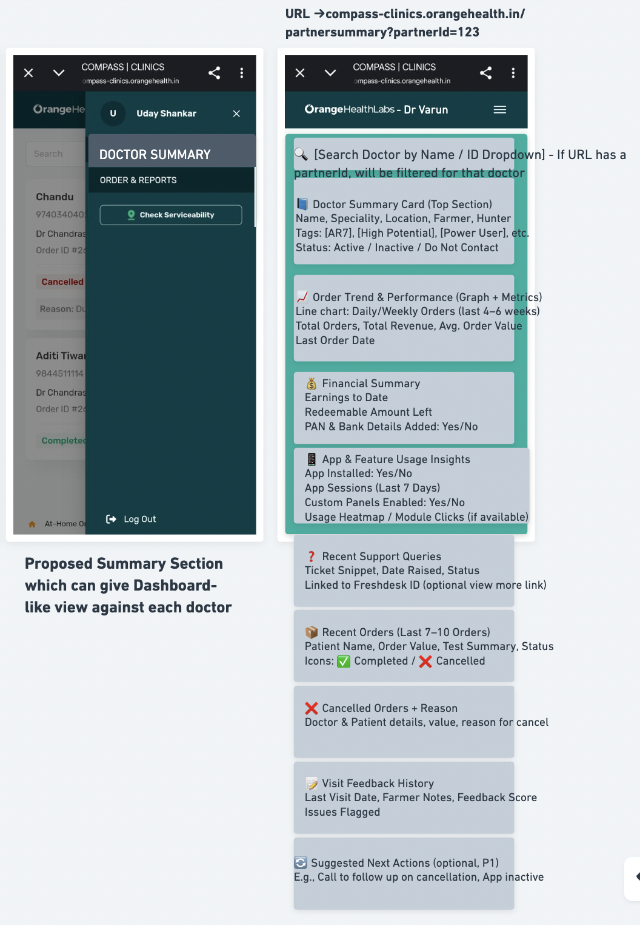

# **Success metrics and Watch metrics**

**Success Metrics**

| **Metric** | **What It Measures** | **Why It Matters** | **Target Direction** |
| --- | --- | --- | --- |
| **Saved Rate from AR Buckets** | % of doctors who move out of AR7/AR40 buckets within 7 days of task | Indicates impact of interventions | Increase |
| **Order Volume from Power Users** | Orders from Power User tagged doctors | Shows if power accounts are being actively farmed | Increase |
| **Churn as % of Starting Portfolio** | What % of portfolio doctors get churned after a period | Indicates impact of proper touch-basing with doctors in a timely manner | Decrease |

**Watch Metrics**

| **Metric** | **What It Measures** | **Why It Matters** | **Target Direction** |
| --- | --- | --- | --- |
| **Missed Visit Tasks per Week** | # of tasks not completed on time | Too many misses can signal overload or poor task relevance | Decrease |
| **Repeat Tasks to Same Doctor within Week** | # of duplicate visit/call tasks to same doctor | Could signal poor prioritization or faulty tagging | Decrease |

# **Impact Assessment**

Intelligent Farming will automate visit planning, task assignment, and doctor-level insights, replacing today’s manual, time-consuming processes.

It will help:

* Managers save time by removing daily planning and tracking work
* Farmers have more informed, effective conversations with doctors
* Leadership get real-time visibility into field execution and outcomes
* Overall, it will drive better doctor engagement, reduce churn, and increase orders from portfolio accounts.

# **Definition of success**

# **GTM**

TBD

# **Events Instrumentation for Analytics**

TBD after Designs/Wireframes

# 